Program 18

Write a python code to obtain a string from user and the calculate total number of capital, small alphabets, digits special character and display the required output?

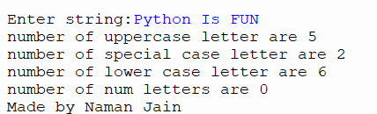

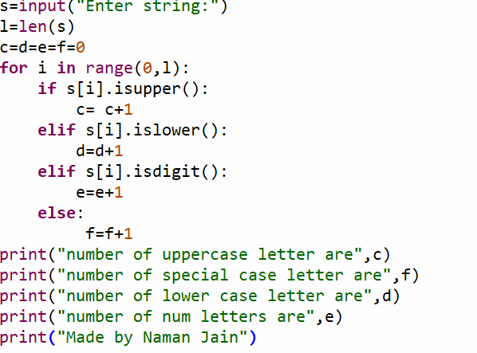

Program 19

Write a program to check the given string is palindrome or not?

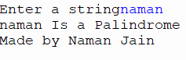

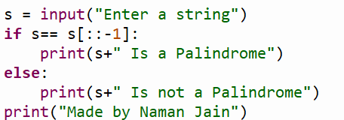

Program 20

Write a program to obtain 3 string from user and then display the lengthier string and by how much?



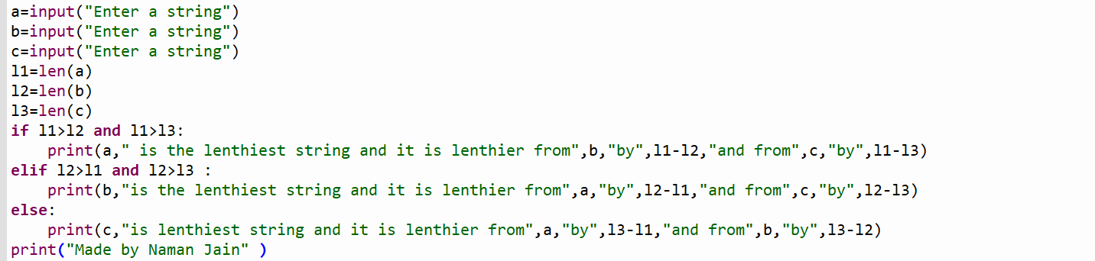

Program, 21

Write a program to obtain a string from user and then display string without spaces?

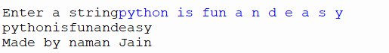

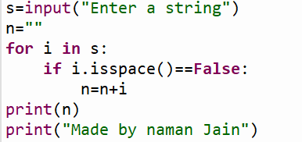

Program 22

Write a program to replace all ‘a’ in a string by symbol ‘@’?

